React.js Component Creation

name : Narra Supriya

email :[supriyanarra14@gmail.com](mailto:supriyanarra14@gmail.com)

phone no :8919413889

Roll NO : 20NN1A1242

College Name : Vignan’s nirula institute of technology and science for women

**source code :**

**CARD COMPONENT :**

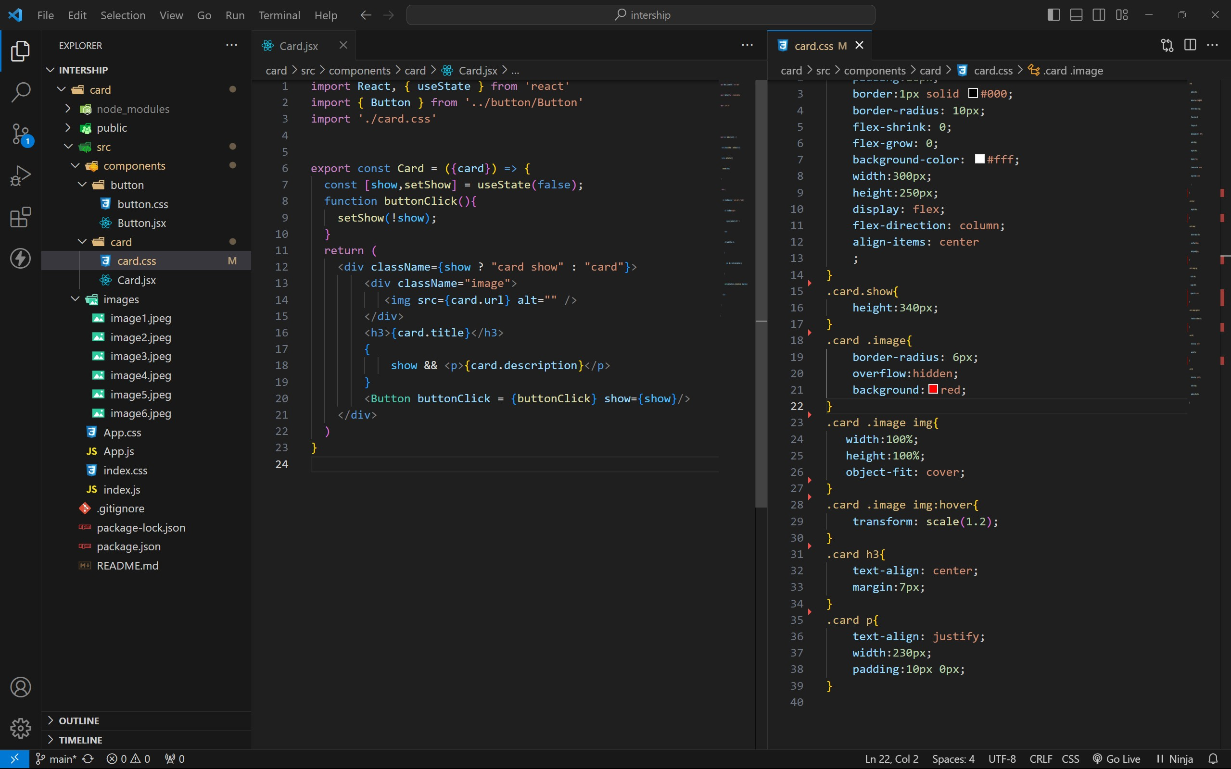

BUTTON COMPONENT :

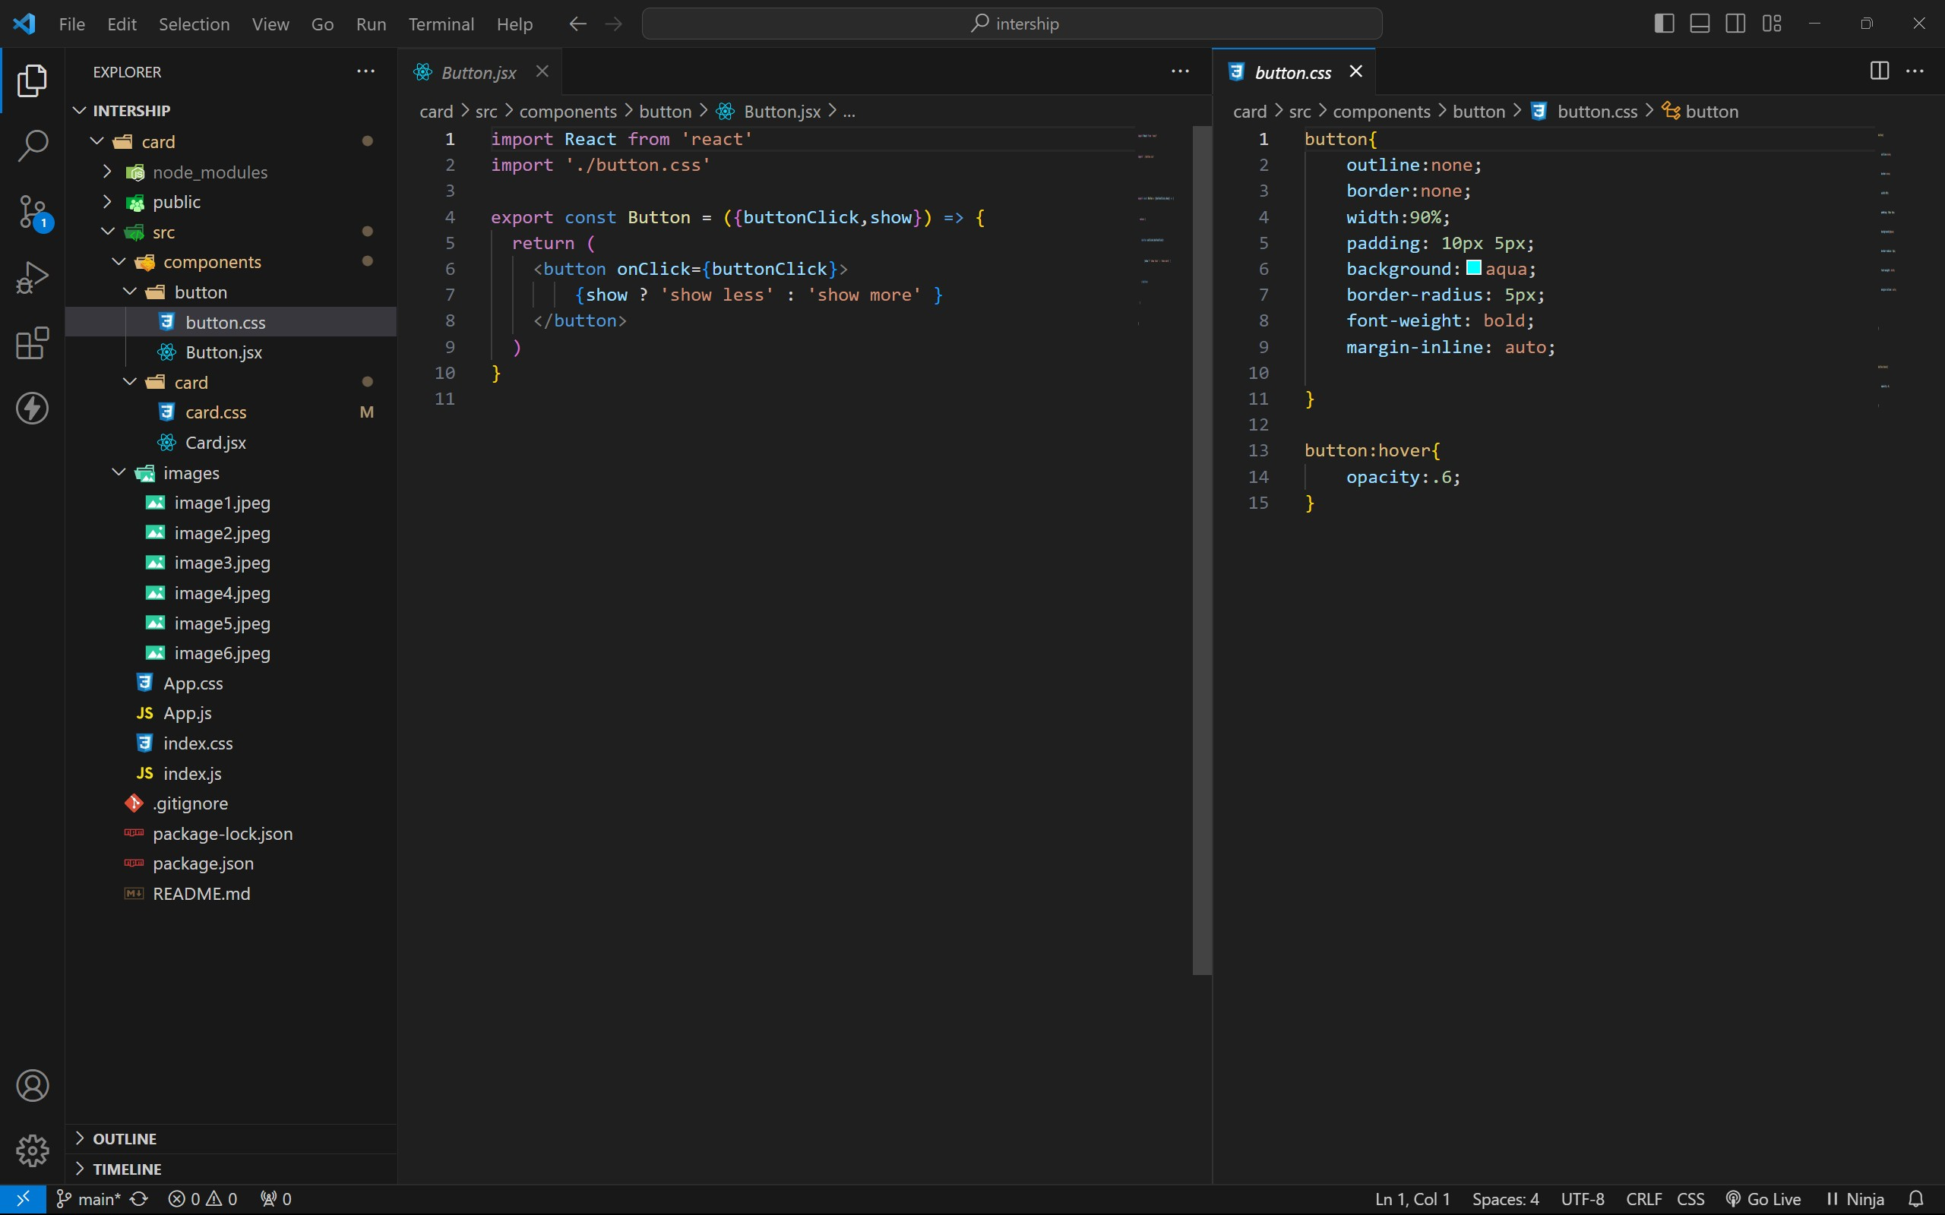

APP COMPONENT :

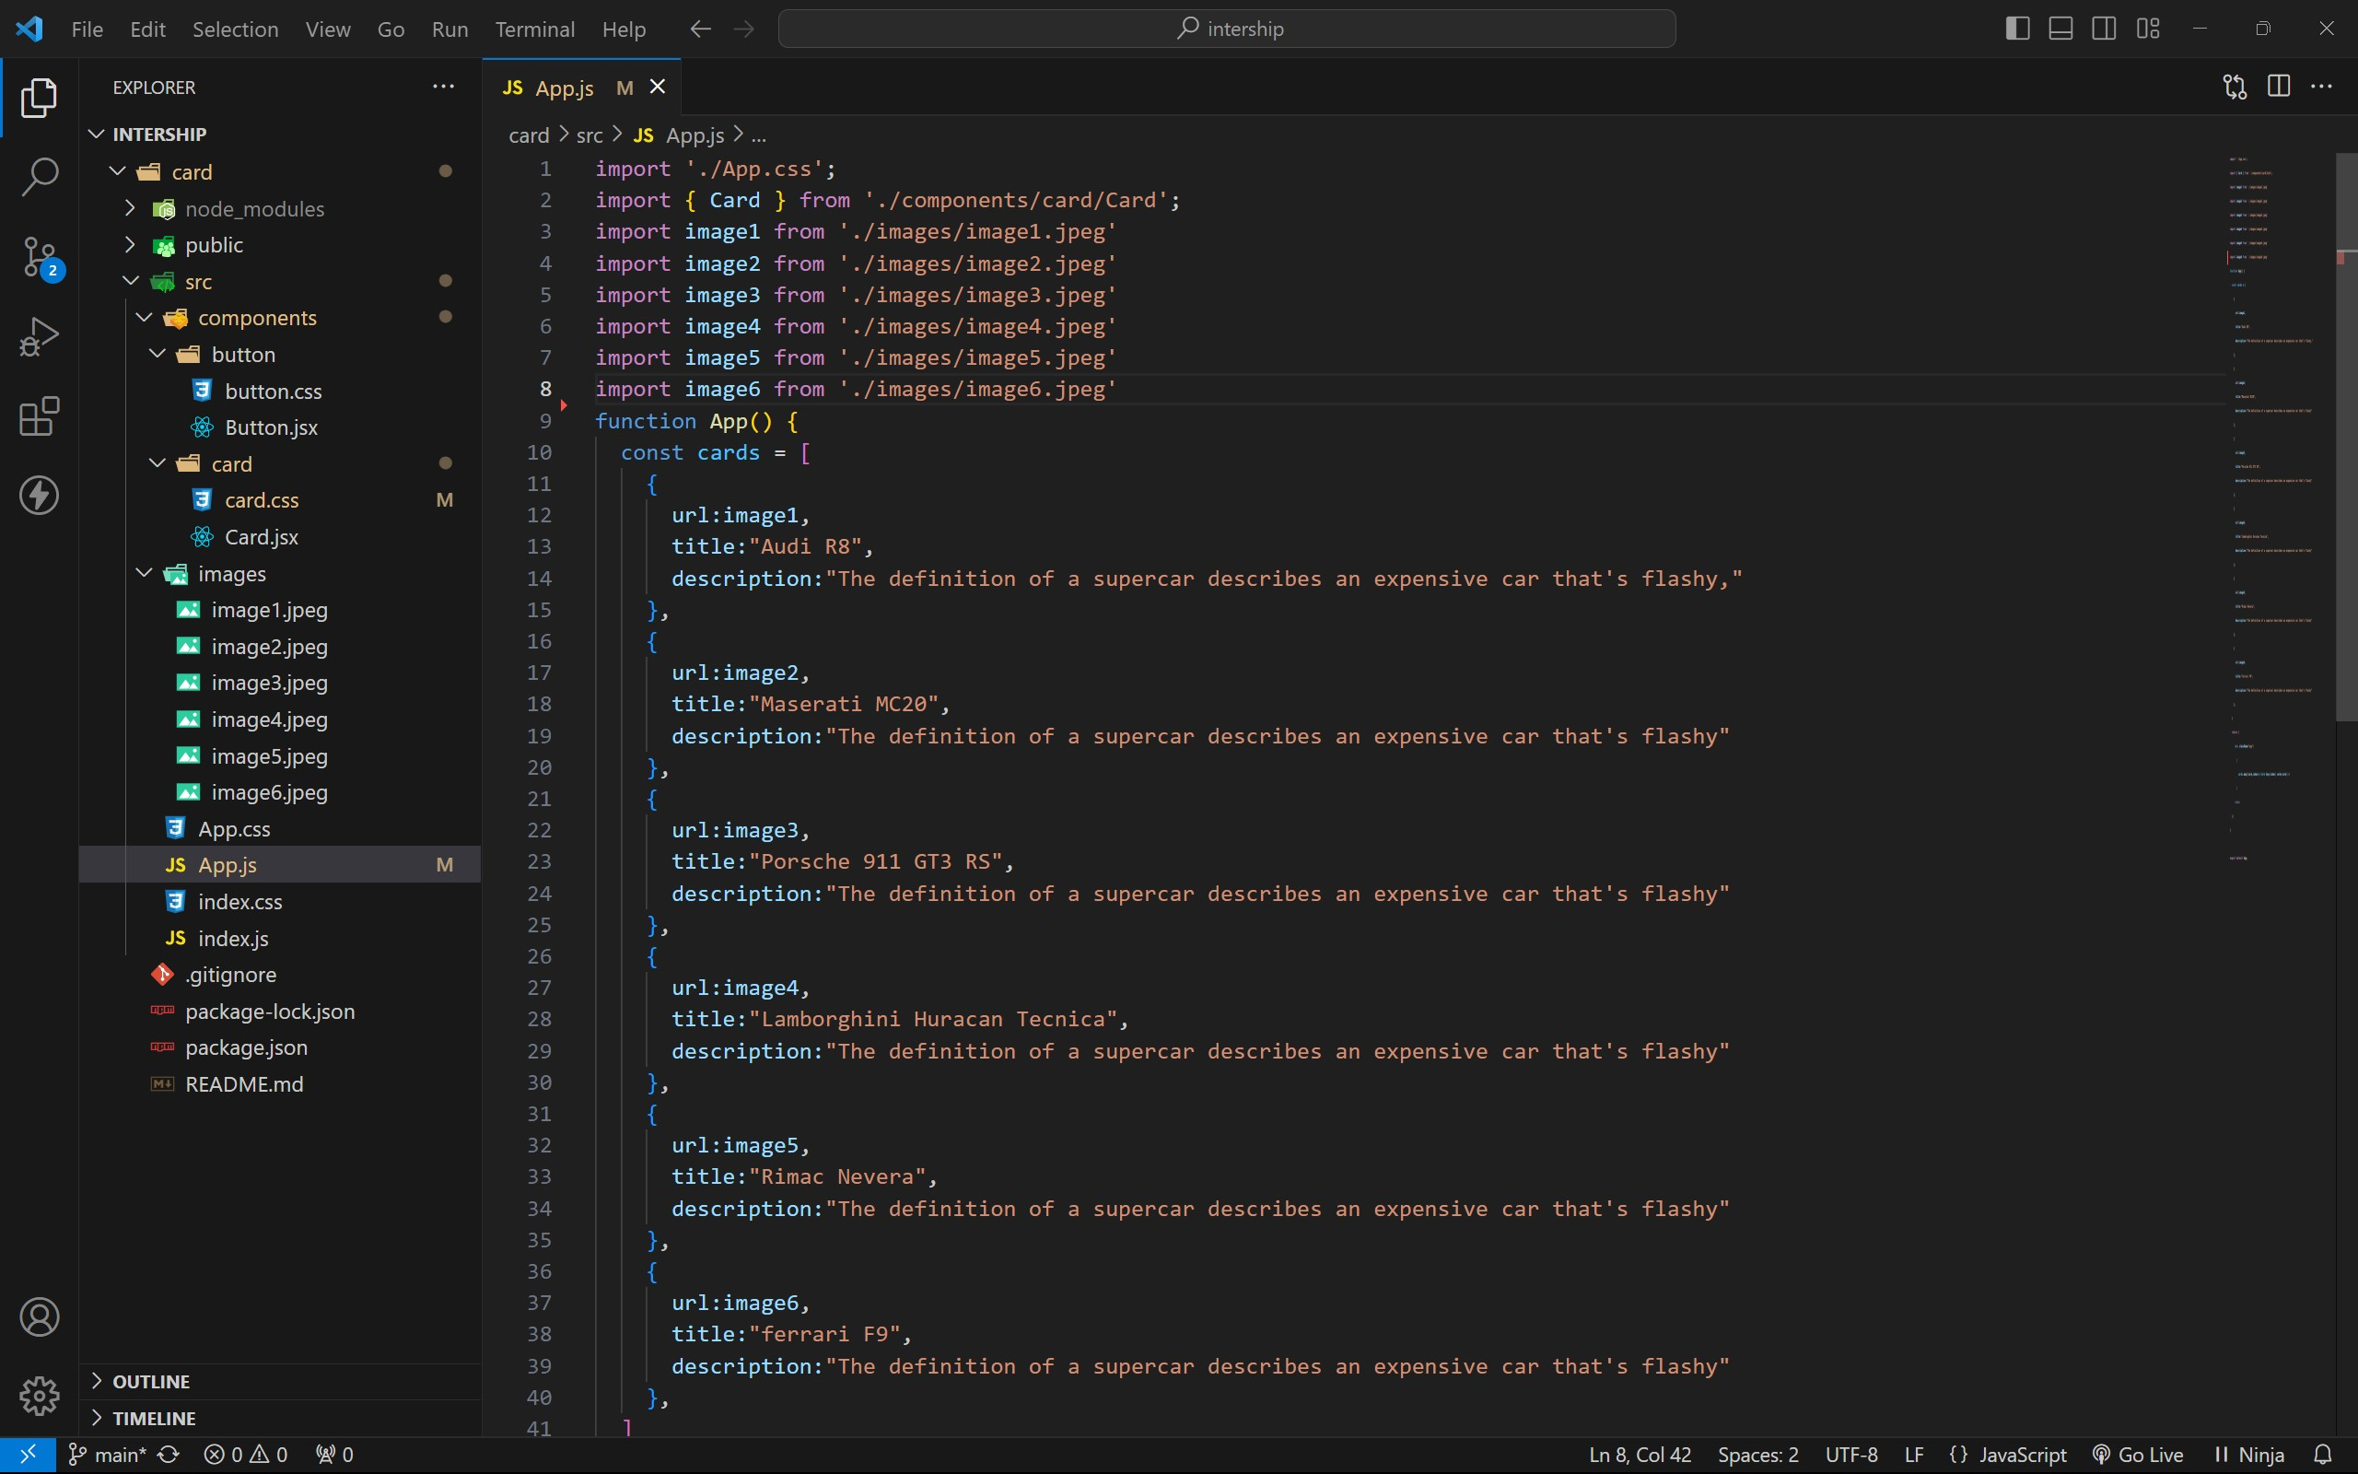

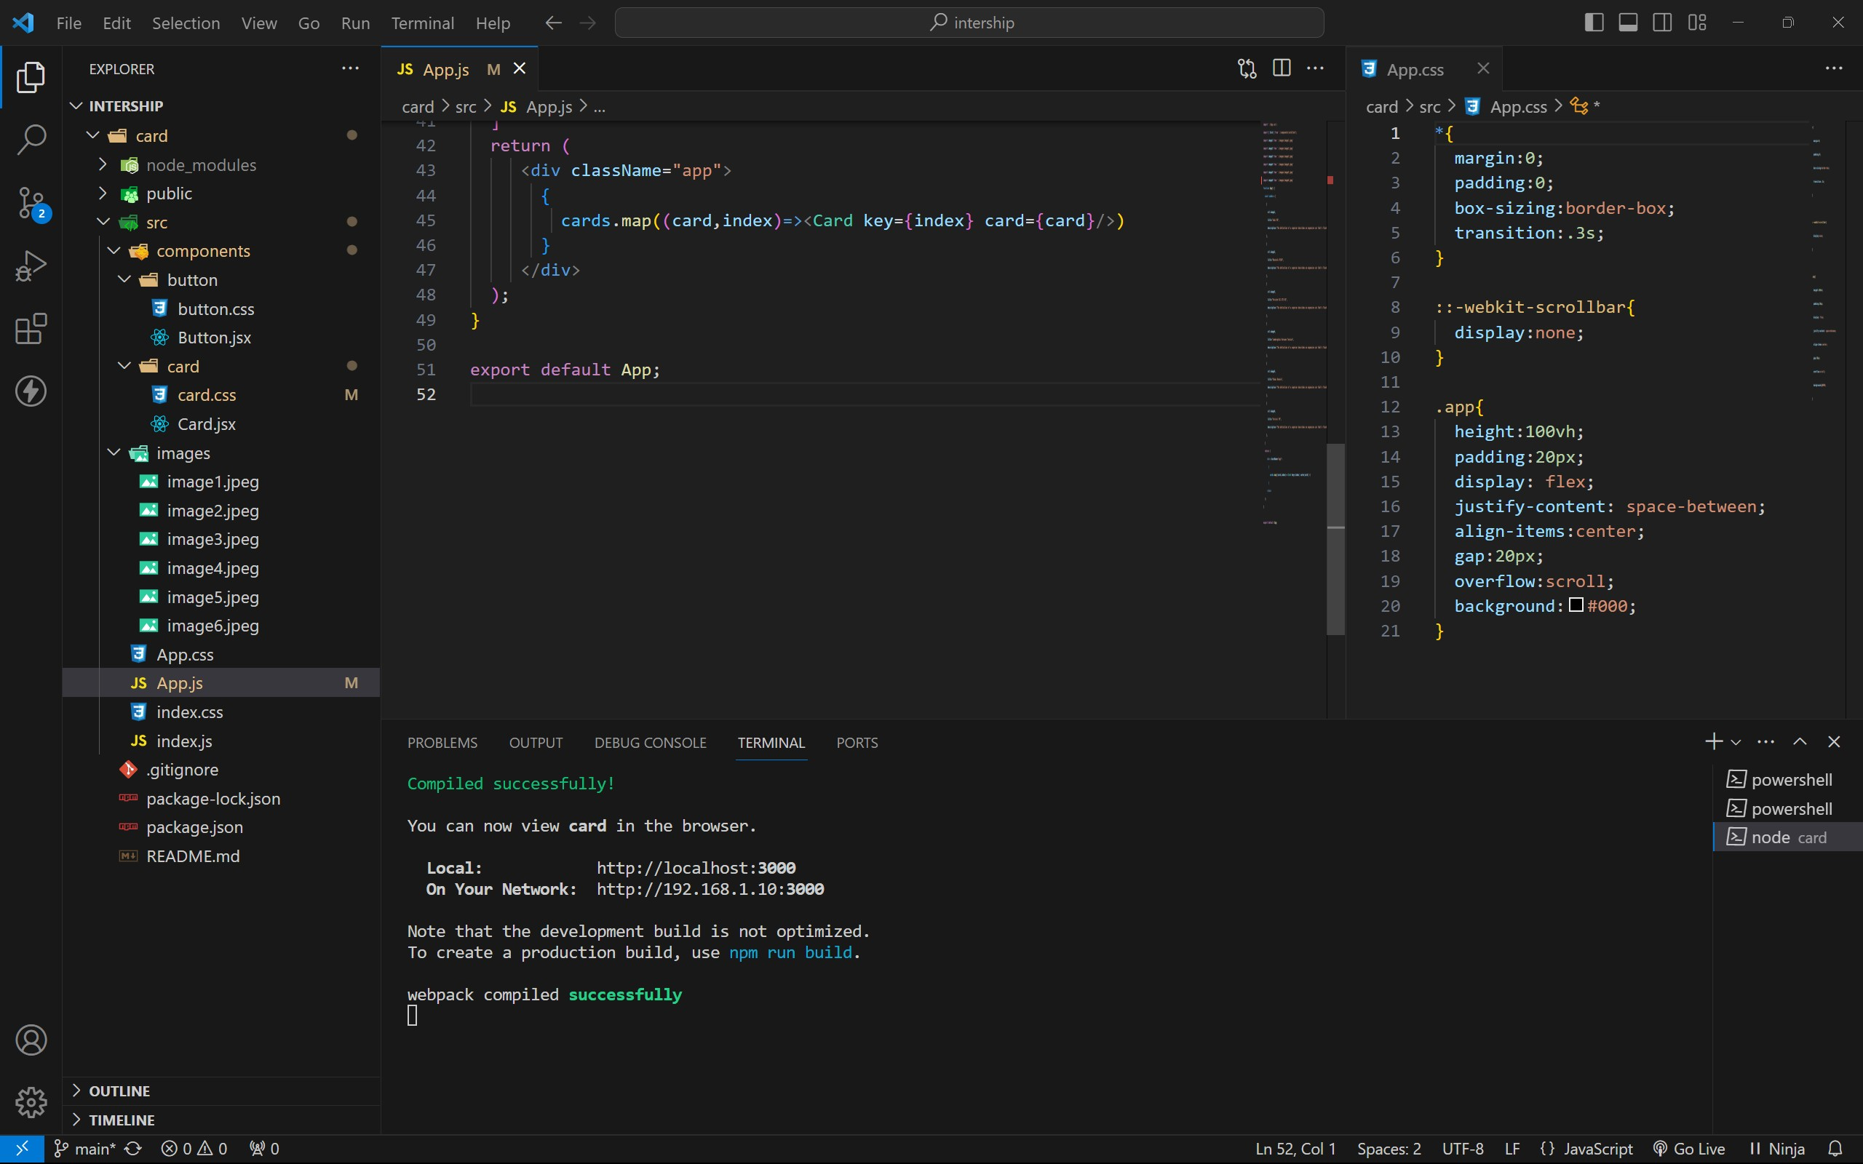

approach :

1 . initially taking an array of objects like below

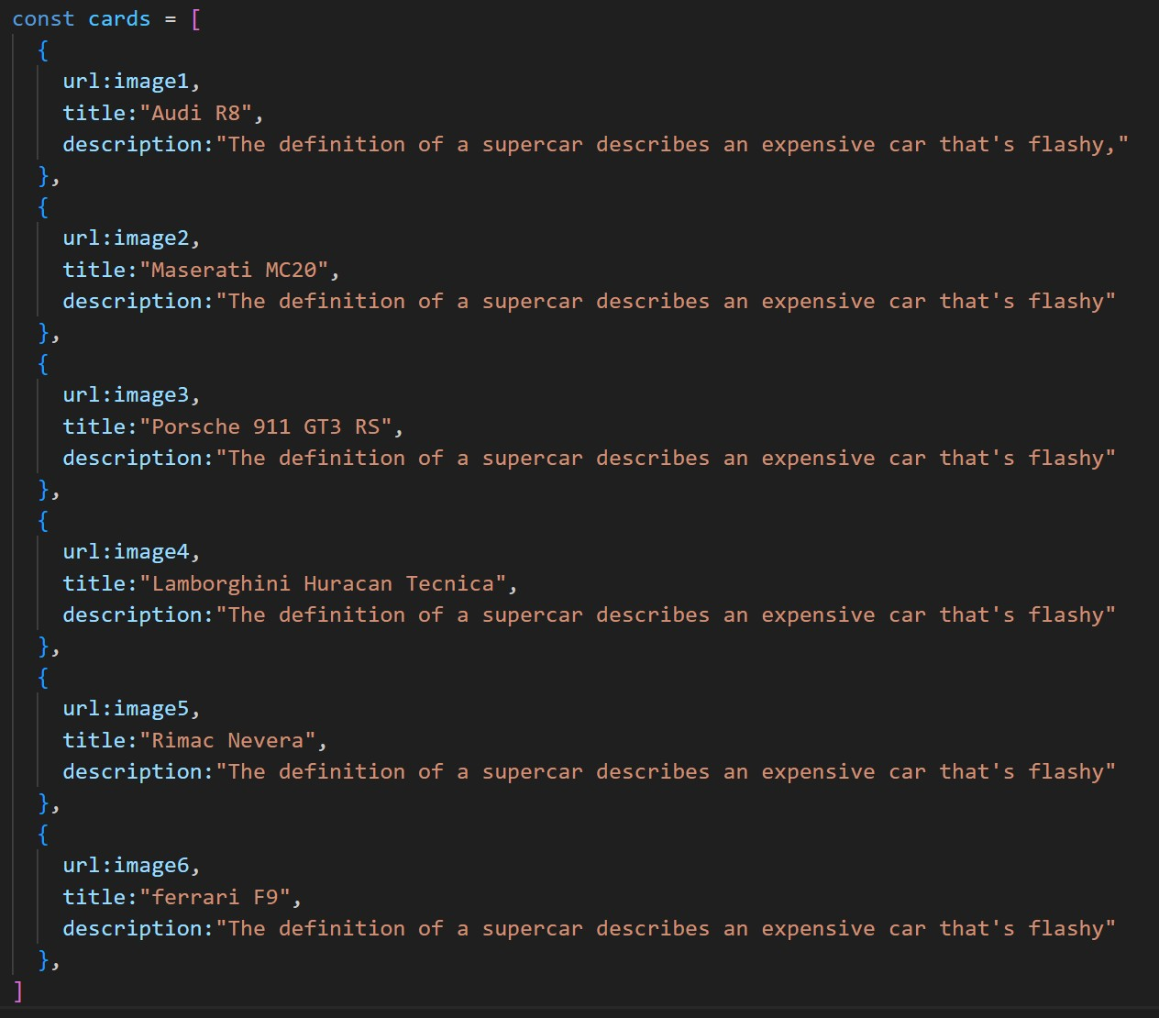

1. **. Passing this card array to child (card component) of App component by using props;**
2. **. getting data as argument like {card} in card component.**
3. **. in card component i use one state [show, setShow] to get extra info as description.**
4. **. When we click the button then show becomes true by assigning setShow (!show) .**

OUTPUT :

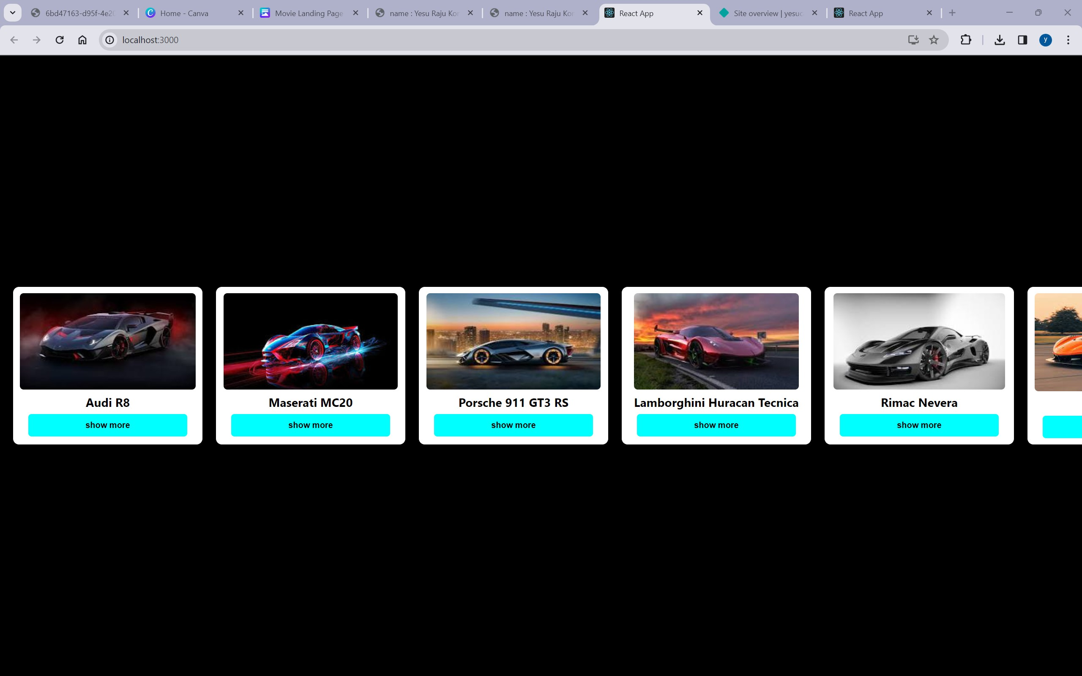

AFTER BUTTON CLICKS :

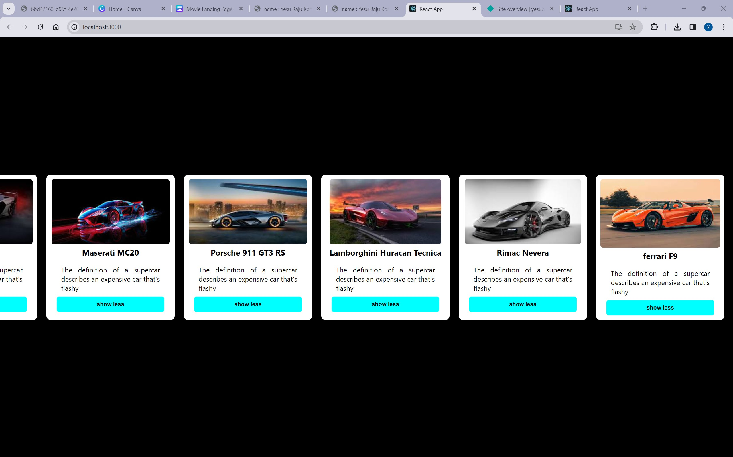

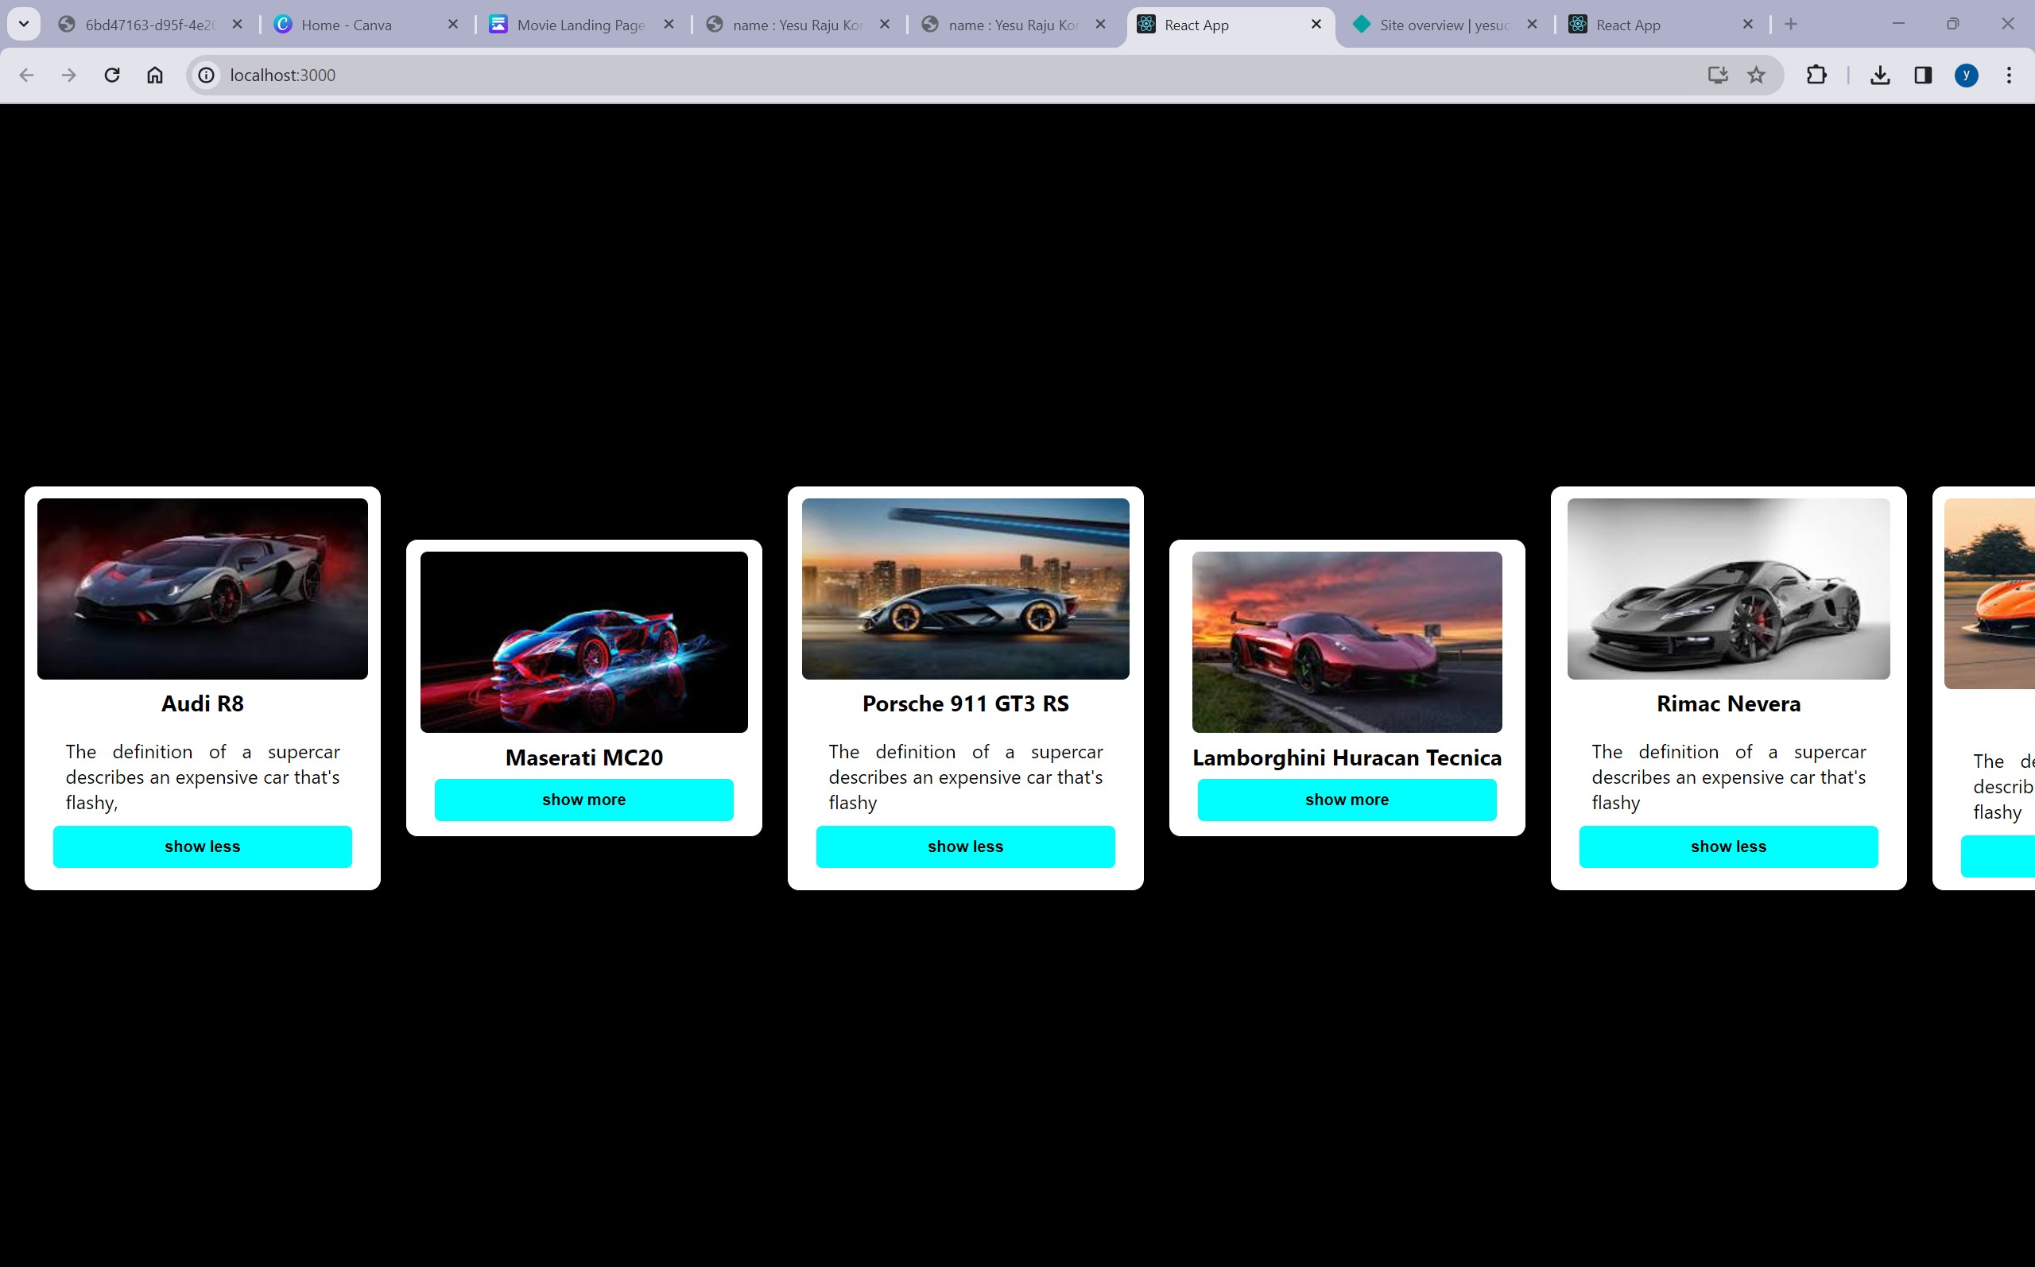

github link : https://github.com/NarraSupriya14